Create a Recovery Services vault

A Recovery Services vault is an entity that stores all the backups and recovery points you create over time. The Recovery Services vault also contains the backup policy applied to the protected files and folders. When you create a Recovery Services vault, you should also select the appropriate storage redundancy option.

To create a Recovery Services vault

1. If you haven't already done so, sign in to the [Azure Portal](https://portal.azure.com/) using your Azure subscription.
2. On the Hub menu, click **All services** and in the list of resources, type **Recovery Services** and click **Recovery Services vaults**.

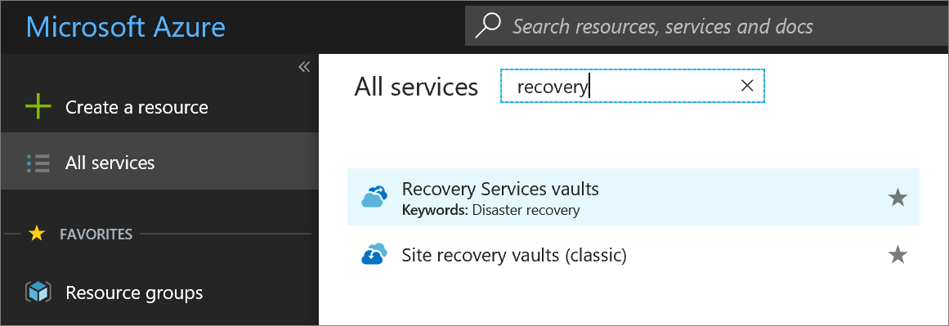

If there are recovery services vaults in the subscription, the vaults are listed.

1. On the **Recovery Services vaults** menu, click **Add**.

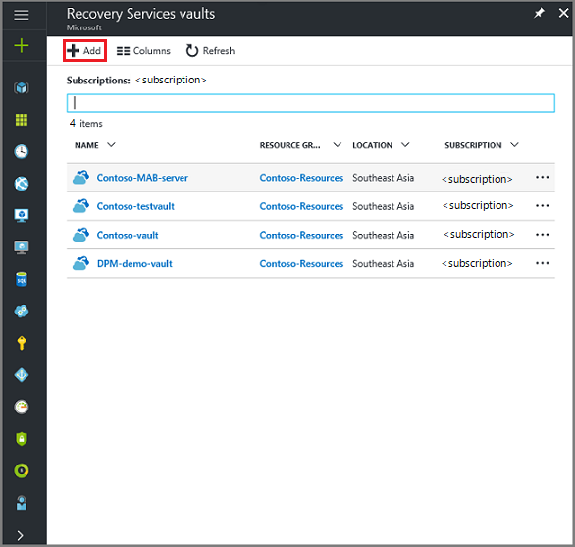

The Recovery Services vault blade opens, prompting you to provide a **Name**, **Subscription**, **Resource group**, and **Location**.

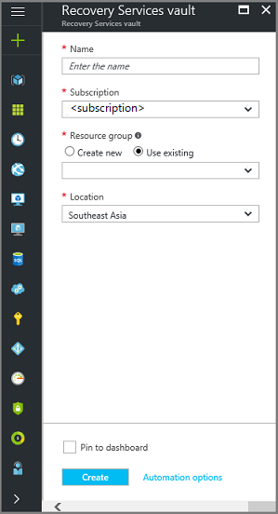

1. For **Name**, enter a friendly name to identify the vault. The name needs to be unique for the Azure subscription. Type a name that contains between 2 and 50 characters. It must start with a letter, and can contain only letters, numbers, and hyphens.
2. In the **Subscription** section, use the drop-down menu to choose the Azure subscription. If you use only one subscription, that subscription appears and you can skip to the next step. If you are not sure which subscription to use, use the default (or suggested) subscription. There are multiple choices only if your organizational account is associated with multiple Azure subscriptions.
3. In the **Resource group** section:
   * select **Create new** if you want to create a new Resource group. Or
   * select **Use existing** and click the drop-down menu to see the available list of Resource groups.

For complete information on Resource groups, see the [Azure Resource Manager overview](https://docs.microsoft.com/en-us/azure/azure-resource-manager/resource-group-overview).

1. Click **Location** to select the geographic region for the vault. This choice determines the geographic region where your backup data is sent.
2. At the bottom of the Recovery Services vault blade, click **Create**.

It can take several minutes for the Recovery Services vault to be created. Monitor the status notifications in the upper right-hand area of the portal. Once your vault is created, it appears in the list of Recovery Services vaults. If after several minutes you don't see your vault, click **Refresh**.

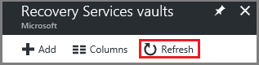

Once you see your vault in the list of Recovery Services vaults, you are ready to set the storage redundancy.

Set storage redundancy

When you first create a Recovery Services vault you determine how storage is replicated.

1. From the **Recovery Services vaults** blade, click the new vault.

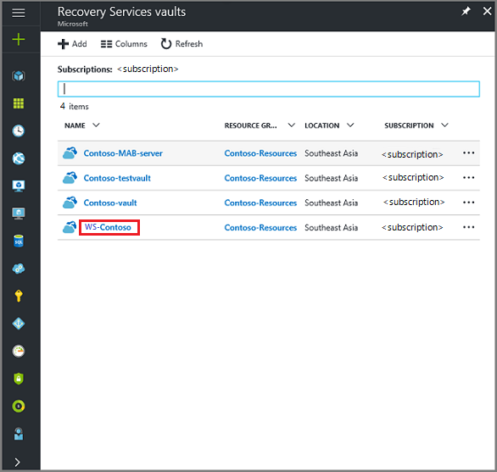

When you select the vault, the **Recovery Services vault** blade narrows, and the Settings blade (*which has the name of the vault at the top*) and the vault details blade open.

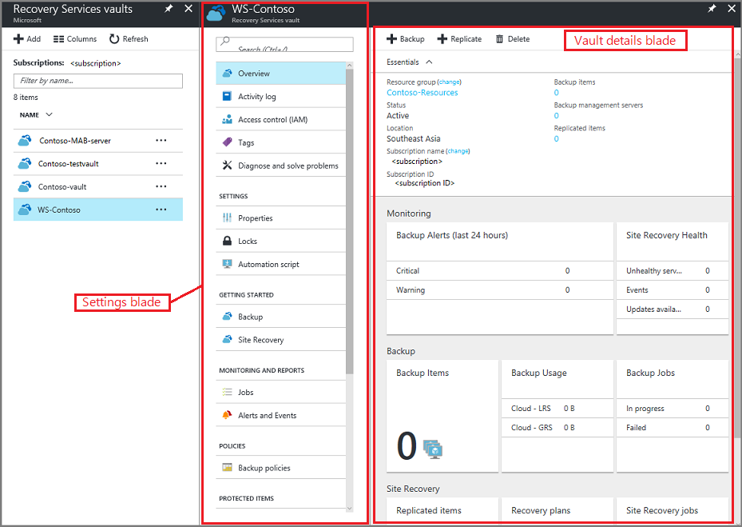

1. In the new vault's Settings blade, use the vertical slide to scroll down to the Manage section, and click **Backup Infrastructure**.

The Backup Infrastructure blade opens.

1. In the Backup Infrastructure blade, click **Backup Configuration** to open the **Backup Configuration** blade.

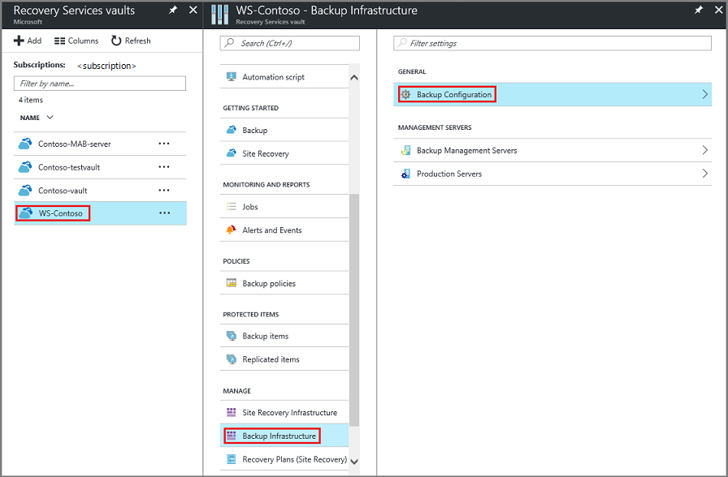

1. Choose the appropriate storage replication option for your vault.

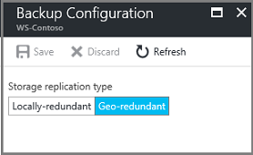

By default, your vault has geo-redundant storage. If you use Azure as a primary backup storage endpoint, continue to use **Geo-redundant**. If you don't use Azure as a primary backup storage endpoint, then choose **Locally-redundant**, which reduces the Azure storage costs. Read more about [geo-redundant](https://docs.microsoft.com/en-us/azure/storage/common/storage-redundancy-grs) and [locally redundant](https://docs.microsoft.com/en-us/azure/storage/common/storage-redundancy-lrs) storage options in this [Storage redundancy overview](https://docs.microsoft.com/en-us/azure/storage/common/storage-redundancy).

Now that you've created a vault, prepare your infrastructure to back up files and folders by downloading and installing the Microsoft Azure Recovery Services agent, downloading vault credentials, and then using those credentials to register the agent with the vault.

Configure the vault

1. On the Recovery Services vault blade (for the vault you just created), in the Getting Started section, click **Backup**, then on the **Getting Started with Backup** blade, select **Backup goal**.

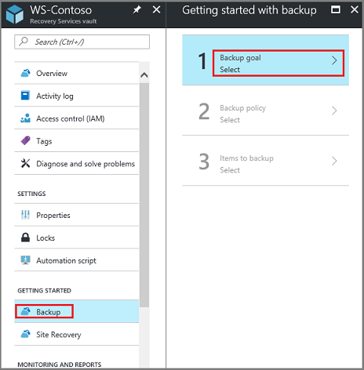

The **Backup Goal** blade opens. If the Recovery Services vault has been previously configured, then the **Backup Goal** blades opens when you click **Backup** on the Recovery Services vault blade.

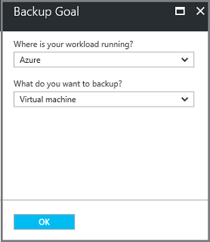

1. From the **Where is your workload running?** drop-down menu, select **On-premises**.

You choose **On-premises** because your Windows Server or Windows computer is a physical machine that is not in Azure.

1. From the **What do you want to backup?** menu, select **Files and folders**, and click **OK**.

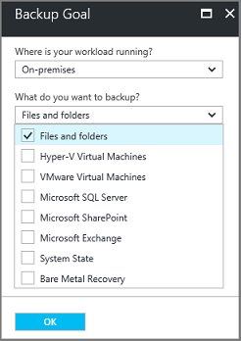

After clicking OK, a checkmark appears next to **Backup goal**, and the **Prepare infrastructure** blade opens.

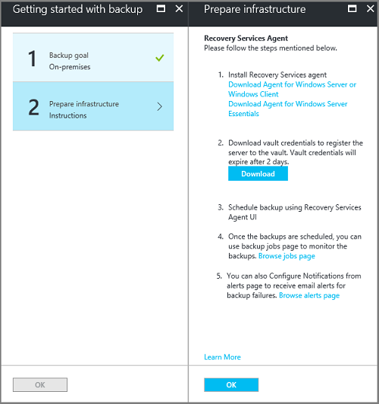

1. On the **Prepare infrastructure** blade, click **Download Agent for Windows Server or Windows Client**.

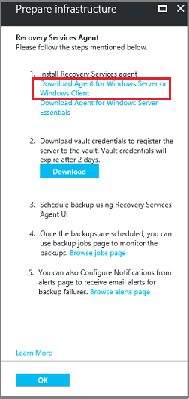

If you are using Windows Server Essential, then choose to download the agent for Windows Server Essential. A pop-up menu prompts you to run or save MARSAgentInstaller.exe.

MARSAgentInstaller dialog

1. In the download pop-up menu, click **Save**.

By default, the **MARSagentinstaller.exe** file is saved to your Downloads folder. When the installer completes, you will see a pop-up asking if you want to run the installer, or open the folder.

prepare infrastructure

You don't need to install the agent yet. You can install the agent after you have downloaded the vault credentials.

1. On the **Prepare infrastructure** blade, click **Download**.

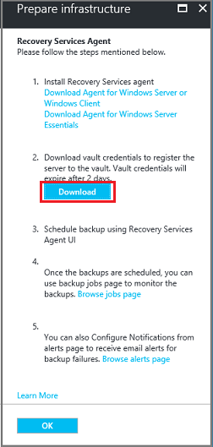

The vault credentials download to your Downloads folder. After the vault credentials finish downloading, you see a pop-up asking if you want to open or save the credentials. Click **Save**. If you accidentally click **Open**, let the dialog that attempts to open the vault credentials, fail. You cannot open the vault credentials. Proceed to the next step. The vault credentials are in the Downloads folder.

vault credentials finished downloading